Week 6 day 5-Friday (13th November)

Agile Project Planning: Building Amazon's Customer Service Portal

About this document
These research notes document explains how a software team plans a big project using Agile, with Amazon's Customer Service page as the example. It is based on the class notes from Week 6, Day 5 (Friday, 13 November).

1. What is Agile?
Agile is a way of building software in small pieces, a little at a time, instead of all at once. The team builds a small part, shows it, gets feedback, and then builds the next part.

A simple example
Think about building a house. In the old way, you plan everything, build everything, and only show the owner at the very end. If the owner does not like the kitchen, it is too late and very costly to change.
In the Agile way, you build one room, show it to the owner, fix what they dislike, then build the next room. Problems are caught early, when they are cheap to fix.

The old way: Waterfall
Before Agile, most teams used Waterfall. Work flows down in fixed steps, like water falling down stairs. You cannot go back up easily.
- Collect all requirements
- Design the whole system
- Build the whole system
- Test the whole system
- Release it to users

Waterfall vs Agile
Point | Waterfall | Agile
How work is done | All at once, in one long flow | In small pieces, again and again
When users see the product | Only at the end | Every few weeks
Changing plans | Hard and costly | Easy and expected
Testing | At the end | All the time
Risk | High: problems found late | Low: problems found early
Good for | Small, fixed, well-known jobs | Big, changing jobs like Amazon

Why Agile suits a project like Amazon
Amazon's needs keep changing. New features come, user numbers grow, and rules change. A plan made on day one will not stay correct for a year. Agile lets the team adjust the plan every few weeks.

Key Agile words you will see
- Sprint: a short fixed period of work, usually 1 to 4 weeks (often 2 weeks).
- Backlog: the to-do list of all work still to be done.
- Product Owner: the person who decides what to build and in what order.
- Scrum: the most popular style of Agile, which uses sprints and daily meetings.
- Stand-up: a short daily meeting (about 15 minutes) where each person says what they did, what they will do, and what is blocking them.

2. The project: Amazon's Customer Service page
In class we pretend we work with Amazon and must build its Customer Service portal. Our job today is not to write code. Our job is to plan: what must be built, and how to split it into pieces.

What is the Customer Service page?
It is the help page a shopper visits after buying something. It is where people go when they ask, "Where is my order?" or "How do I send this back?"

What the user must be able to do
What the user wants | Example from real life
Track an order | "My phone was shipped. Where is it now?"
Edit or cancel an order | "I chose the wrong size. Let me change it before it ships."
Return or refund an item | "The shoes do not fit. I want my money back."
Exchange an item | "Send me the same shirt in blue instead."
Print a return label | "I need a sticker to put on the box I am sending back."
Manage addresses (more than one) | "Send this gift to my mother's house, not mine."
Manage Prime membership | "Renew, cancel, or check my Prime plan."

Where the plan comes from
The team does not guess what to build. The client (Amazon) or its product development team gives us a wireframe: a rough drawing of the page. The next section explains what a wireframe is.

The first question every team must ask
Before planning, always ask two questions:
- What do we need to build? (the full list of things the page must do)
- What are the pieces to be built? (how we split that list so many people can work on it)
The rest of this guide answers these two questions step by step.

3. What is a wireframe?
A wireframe is a simple, rough drawing of a page that shows where things go, not how pretty they look. It is like the pencil sketch an architect makes before drawing the full house.

Features of a wireframe
- It is usually black and white (or grey). No colours, no real photos, no fancy fonts.
- Boxes stand for pictures, buttons, menus and text.
- It shows the layout: what is on top, what is on the side, what is in the middle.
- It shows the main parts of the page, so the team knows what to build.

Who decides the wireframe?
The Product Owner decides what the product should look like and what it should do. The wireframe is their way of telling the team, "This is the basic idea."

Class example: YouTube
In class we first looked at a wireframe of YouTube. Even without colours, you can see the parts: a search bar on top, a menu on the left, and a grid of video boxes in the middle. Each box is a piece the team will build.

Why wireframes matter
A wireframe stops arguments later. Everyone agrees on the layout before any code is written. Changing a drawing takes minutes. Changing finished code takes days.

Wireframe vs mockup vs prototype
Name | What it is | Looks like the final product?
Wireframe | Rough layout sketch, black and white | No
Mockup | Full design with colours, fonts and images | Yes, but you cannot click it
Prototype | A clickable model that acts like the real app | Almost, but it has no real data

4. The people in the team
Each person has one clear job: the Product Owner decides what, the Architect and Tech Lead decide how, and the engineers build it.
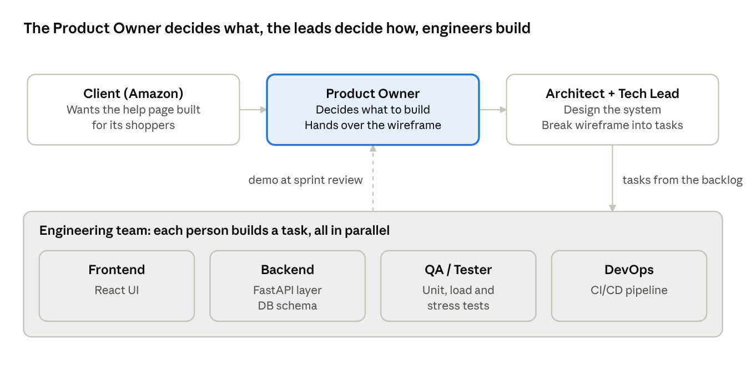
How work moves through the team
Work flows left to right and then down to the engineers; the dashed arrow shows finished work going back to the Product Owner for review every sprint.

Who does what
Role | Main job | In our Amazon project
Client | The company paying for the work | Amazon
Product Owner | Decides what the product should do and look like; sets priorities | Gives us the wireframe of the Customer Service page
Architect | Designs the overall system: which parts, how they connect, how it handles millions of users | Plans the database, servers and how tracking data flows
Tech Lead | Breaks the page into pieces and gives work to engineers; guides the team on code | Splits the wireframe into features and tasks
Scrum Master | Runs the Agile process and removes blockers | Runs sprint meetings and daily stand-ups
Engineers (developers) | Write the code | Build the React screens, FastAPI layer and database
QA / Testers | Check that everything works and does not break under load | Run unit, load and stress tests
DevOps | Set up the systems that build, test and release code automatically | Configure the CI/CD pipeline

How the work flows between them
- The Product Owner hands over the wireframe and the list of needs.
- The Architect and Tech Lead break down the wireframe into smaller pieces, so it can be shared out to the engineering team.
- The pieces go into the backlog (the team's to-do list).
- Engineers pick up pieces and build them in parallel (at the same time).
- Testers check each piece; DevOps makes sure it can be released safely.
Step 2 is the heart of today's class. The next section shows exactly how that breakdown works.

5. The Agile work ladder: Epic, Feature, User Story, Task
Agile splits big work into four levels, from biggest to smallest: Epic → Feature → User Story → Task. Each level is cut into many pieces of the level below.
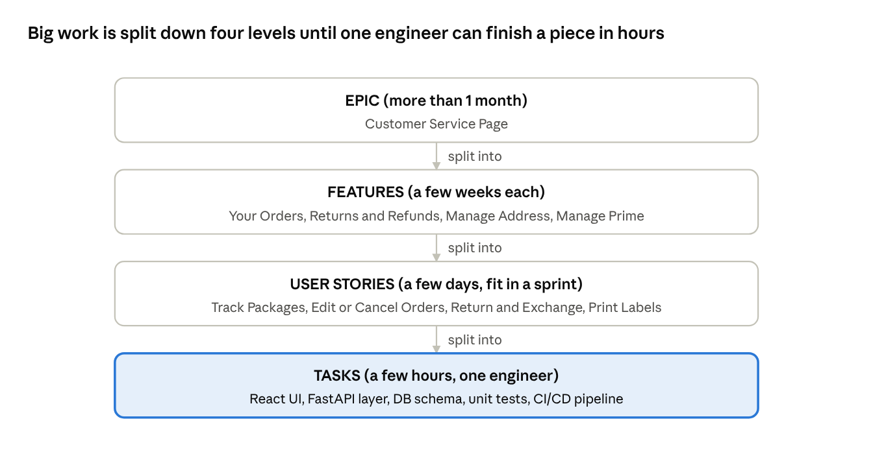
Agile work ladder · 4 levels
Read it top to bottom: each level is cut into several pieces of the level below. Engineers work at the bottom level (highlighted).

Level 1: Epic
An Epic is a very big piece of work. From an Agile point of view, anything that takes more than a month to build is an Epic.
- Our Epic: Customer Service Page.
- An Epic is too big for one person or one sprint. It must be broken down.

Level 2: Feature
A Feature is a main part of the Epic that gives the user a clear ability. It usually takes a few weeks.
- Our Features: Your Orders, Returns and Refunds, Manage Address, Manage Prime.

Level 3: User Story
A User Story describes one thing a user wants to do, written from the user's point of view. It usually fits inside one sprint (a few days to two weeks).
User stories are often written in this simple pattern:
As a [type of user], I want to [do something], so that [I get some benefit].
Example: As a shopper, I want to track my package, so that I know when it will arrive.
- Our User Stories: Track Packages, Edit or Cancel Orders, Return and Exchange Items, Print Labels.

Level 4: Task
A Task is a small technical job that one engineer can finish in a few hours (often under a day). Tasks are what engineers actually work on.
- Example Tasks for Track Packages: build the React UI, build the FastAPI layer, build the database schema, write unit tests, set up the CI/CD pipeline.

The four levels at a glance
Level | Size | Usual time | Who writes it | Our example
Epic | Huge | More than 1 month | Product Owner | Customer Service Page
Feature | Large | A few weeks | Product Owner with Tech Lead | Your Orders
User Story | Medium | A few days, fits in a sprint | Product Owner / team | Track Packages
Task | Small | A few hours | Tech Lead / engineers | Build the React UI (5 hrs)

Easy way to remember
Think of a book. The Epic is the whole book. Features are chapters. User Stories are pages. Tasks are the sentences on each page.

6. Breaking down the Customer Service Epic
The Customer Service Epic splits into 4 Features, and each Feature splits into User Stories. The tree below shows the full breakdown from class; the grey boxes are stories the class did not list, added here as sensible examples.
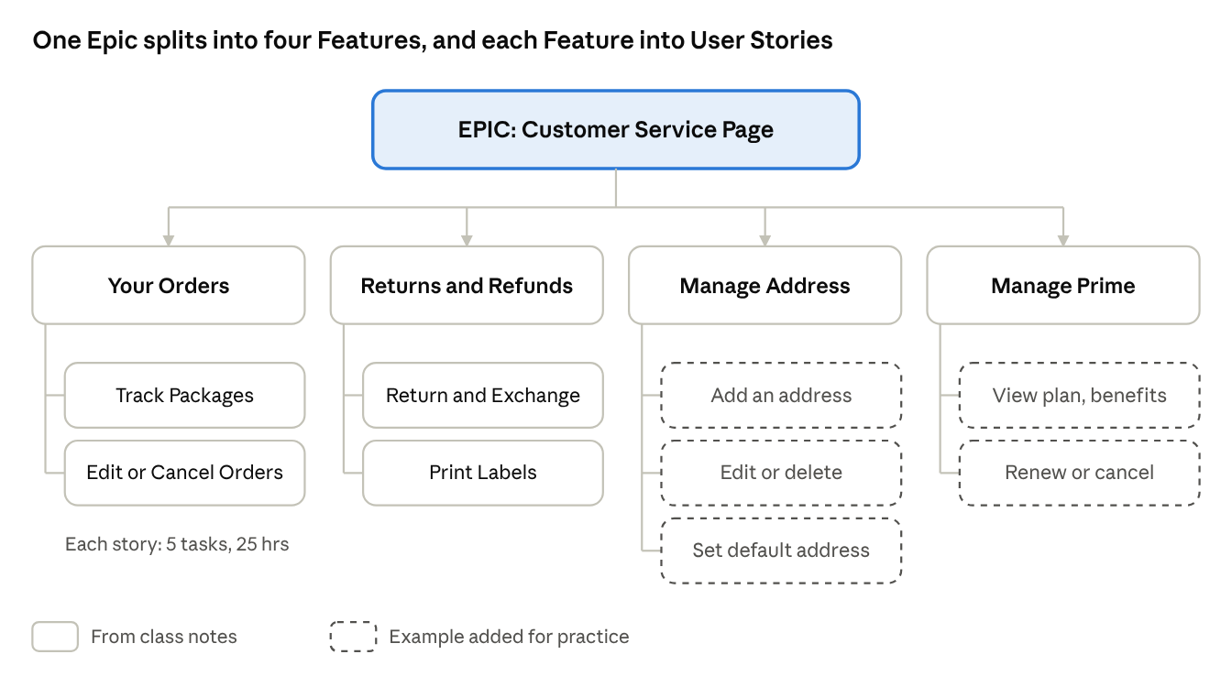
Customer Service Epic breakdown · 1 Epic, 4 Features, 9 Stories

Step 1: Epic → Features
Feature | What it lets the user do
Your Orders | See all past and current orders, track them, change or cancel them
Returns and Refunds | Send items back and get money back or a swap
Manage Address | Add, edit, delete and choose from many delivery addresses
Manage Prime | View, renew, change or cancel a Prime membership

Step 2: Features → User Stories
Feature: Your Orders
- Track Packages: As a shopper, I want to see where my package is, so that I know when it will arrive.
- Edit or Cancel Orders: As a shopper, I want to change or cancel my order before it ships, so that I do not get the wrong item.
Feature: Returns and Refunds
- Return and Exchange Items: As a shopper, I want to return or swap an item, so that I get my money back or the right product.
- Print Labels: As a shopper, I want to print a return label, so that the courier knows where to send my box.
Feature: Manage Address (example stories, not from class)
- Add a new address
- Edit or delete an address
- Set a default address
Feature: Manage Prime (example stories, not from class)
- View Prime plan and benefits
- Renew or cancel Prime

Step 3: User Stories → Tasks
Every User Story is then cut into technical Tasks. The next section shows this for Track Packages and Edit Orders.

Acceptance criteria: how we know a story is done
Each user story should have a short checklist called acceptance criteria. The story is only "done" when every point is true. Example for Track Packages:
- ☐ The user can see a list of their orders with a status for each.
- ☐ The user can open an order and see each step of its journey.
- ☐ The expected delivery date is shown.
- ☐ The page loads in under 2 seconds, even at busy times.
- ☐ The page works on phone and computer.

7. Tasks and time estimates
Each User Story becomes 5 Tasks that add up to 25 hours of work, so Track Packages plus Edit Orders come to 50 hours in total.

Tasks for "Track Packages" and "Edit Orders"
Both stories use the same 5 tasks with the same hours, because both need a screen, a server layer, a database, tests and a release pipeline.
# | Task | What it means in simple words | Who usually does it | Track Packages (hrs) | Edit Orders (hrs)
1 | Build the DB Schema | Design the tables that store orders, items and tracking events | Backend engineer | 8 | 8
2 | Build the FastAPI Layer | Write the server code that reads and changes data and sends it to the screen | Backend engineer | 6 | 6
3 | Build the React UI | Build the screen the shopper sees and clicks | Frontend engineer | 5 | 5
4 | Write Unit Test Cases | Write small automatic checks that prove each piece works | Same engineer or QA | 4 | 4
5 | Configure CI/CD pipeline | Set up automatic build, test and release for this feature | DevOps engineer | 2 | 2
 | Total |  |  | 25 | 25
The database schema takes the longest (8 hrs, about one third of the story) because every other part depends on getting the data right.

What each technology is
- React: a JavaScript library for building the parts of a web page users see and click (the front end).
- FastAPI: a Python tool for building APIs. An API is the messenger between the screen and the database. The screen asks, "Give me order 123," and the API fetches it.
- DB Schema: the plan of the database: which tables exist, which columns each has, and how tables link. For example, an Orders table linked to a Tracking Events table.
- Unit tests: small pieces of code that check one function at a time. Example: "If an order is already shipped, cancelling must fail."
- CI/CD: Continuous Integration / Continuous Delivery. Every time code is saved, a robot builds it, runs the tests, and (if all pass) releases it. This catches mistakes fast.

The order of work inside one story
Some tasks depend on others. A sensible order is:
- DB Schema first: the data must have a home.
- FastAPI layer next: it reads and writes that data.
- React UI: it shows the data from the API. (The UI can start early using fake sample data, so frontend and backend engineers work at the same time.)
- Unit tests: written alongside each piece, not only at the end.
- CI/CD: so every change is built and tested automatically.

Why break work into hours at all?
- Planning: the Tech Lead can see how much fits into one sprint.
- Sharing work: each task goes to a different engineer, and they work in parallel.
- Tracking progress: it is easy to see what is done and what is late.
- Spotting risk: if a task is estimated at 40 hours, it is too big and must be split again. A good rule: no task over about 1 day (8 hours).

8. Can 20 people build this in 30 days?
No. Writing the basic code might fit in 30 days, but making it work safely for millions of users at once does not.

The simple maths (and why it misleads)
On paper the team looks big enough:
- 20 engineers × about 22 working days × about 6 focused hours a day = about 2,640 hours.
- Our sample stories need only 25 hours each.
So why not? Because those 25 hours are only the "happy path" code. They do not include the hard parts listed below.

What the hours do not show
Hidden work | Why it takes long
Huge number of users | The page must serve millions of people at the same time without slowing down or crashing
Complex tracking logic | A package passes through many hands and places; following it correctly is a hard problem (Section 9)
Load and stress testing | Every feature must be tested under heavy traffic before release (Section 10)
Connecting to other systems | Payments, warehouses, couriers and Prime billing are all separate systems that must talk to ours
Security and privacy | Addresses and payment data must be protected; this needs reviews and checks
Bug fixing and rework | Problems found in testing send work back to engineers
Meetings and coordination | 20 people need planning, reviews and stand-ups; more people means more talking

Scale: why India matters
India is one of the largest user bases for many global companies. For a shopping site, this means:
- Very heavy traffic during sale events and festivals (for example, Diwali sales).
- Many users on mobile phones and slower networks, so pages must be light and fast.
- Users across many cities and pin codes, so the delivery network and tracking data are huge.
- Support for different languages and payment methods.
Because of this, the team cannot move on from the development phase until features like "Your Orders" pass stress and load testing.

Adding more people does not always help
There is a famous idea in software called Brooks's Law: adding people to a late project makes it later. New people need time to learn, and every new person adds more communication. Nine women cannot make a baby in one month.

So what is the realistic answer?
The Epic is planned over several months, in many 2-week sprints. Each sprint delivers a few working user stories. The most important stories (like Track Packages) are built and released first; less urgent ones (like Manage Prime extras) come later.

9. The tracking interface: following a package's journey
Tracking is the hardest part of the page, because one package passes through many places and companies, and each one sends updates at different times.

The journey of a product
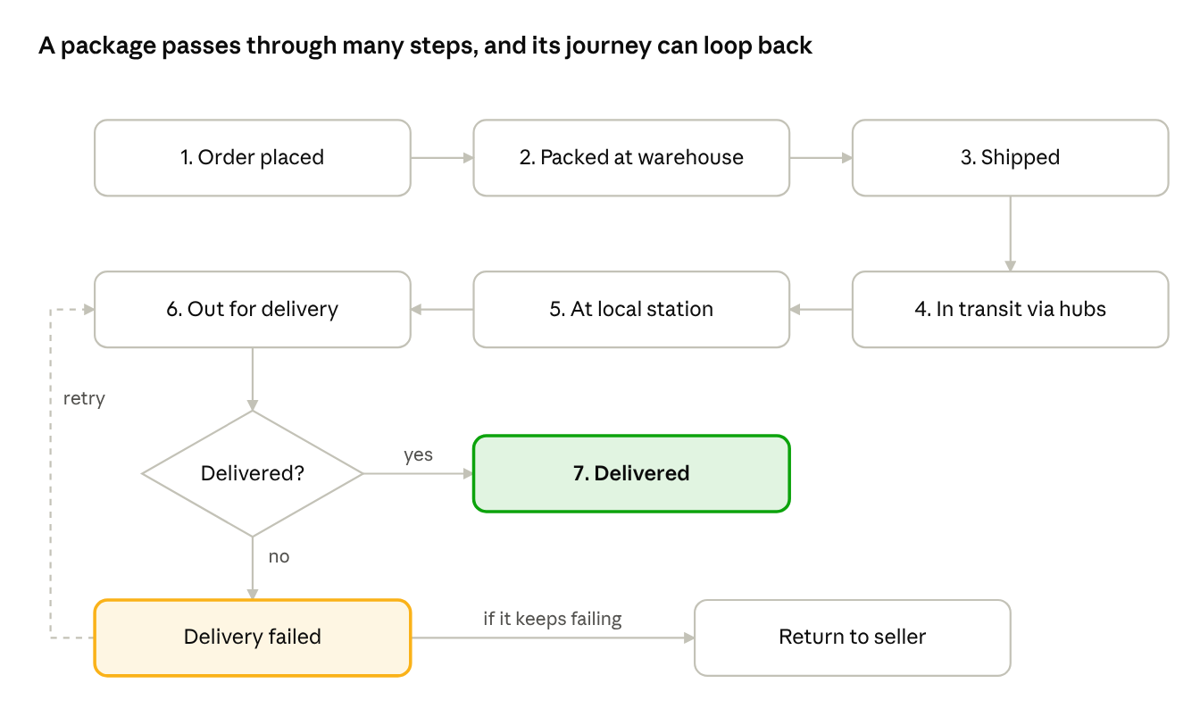
Package journey · 7 steps, 1 retry loop
At every step, a scan or event is recorded: "Packed at warehouse", "Left sorting centre", "Out for delivery" and so on. The tracking page reads these events and shows them in order.

Why the algorithm is complicated
Problem | Simple example
Many sources of data | Amazon's warehouse, a partner courier and a local delivery agent each send their own updates
Events arrive late or out of order | "Delivered" reaches our system before "Out for delivery" because of a network delay
Missing scans | A truck forgets to scan a parcel at one hub, so there is a gap in the journey
Split orders | One order of 3 items ships in 2 boxes from 2 warehouses, with 2 different journeys
Estimated delivery date | The date must be re-calculated when a truck is late or the weather is bad
Failed delivery and return-to-sender | The journey can loop back instead of only moving forward
Huge volume | Millions of packages create a very large number of tracking events every day

How a simple tracking design works
- Store events, not just a status. Keep a Tracking Events table: order ID, package ID, event type, place, time. The "current status" is the latest valid event.
- Sort by the time the event happened, not the time it arrived in our system. This fixes out-of-order updates.
- Define allowed steps (a "state machine"). For example, "Shipped" can go to "In transit", but "Delivered" cannot go back to "Packed". Strange jumps are flagged.
- Track each package separately when an order is split.
- Update the estimated delivery date whenever a new event arrives.
- Use caching so that millions of "Where is my order?" checks do not hit the main database every time.

A simple DB schema for tracking
Table | Main columns | Purpose
Orders | order_id, user_id, order_date, total | One row per order
Packages | package_id, order_id, courier, expected_date | One order can have many packages
Tracking_Events | event_id, package_id, status, location, event_time | One row per scan in the journey
Addresses | address_id, user_id, line1, city, pin_code, is_default | Supports many addresses per user
This is a beginner-friendly version. A real Amazon system would be split across many services and databases.

10. Testing at scale, CI/CD and parallel work
For a site with millions of users, code that "works on my laptop" is not enough: it must be proven to work under heavy traffic, and released safely many times a day.

Types of testing
Test type | Question it answers | Example for "Your Orders"
Unit test | Does one small function work? | Does cancel_order() refuse to cancel a shipped order?
Integration test | Do the parts work together? | Does the React page show what the FastAPI layer returns from the DB?
End-to-end test | Does the whole journey work like a real user? | Log in, open orders, cancel one, see "Cancelled"
Load test | Does it stay fast at the expected traffic? | 1 lakh users open "Your Orders" at the same time; pages still load in under 2 seconds
Stress test | When does it break, and how does it recover? | Keep adding users until the system fails; check it fails safely and comes back
Spike test | Can it handle a sudden jump? | Traffic jumps 10 times in one minute when a Diwali sale starts
The numbers above are classroom examples, not real Amazon figures.

Load test vs stress test
- Load test: fill a bridge with the normal number of cars and check it is fine.
- Stress test: keep adding cars until the bridge starts to crack, to learn its limit.

CI/CD pipeline in simple steps
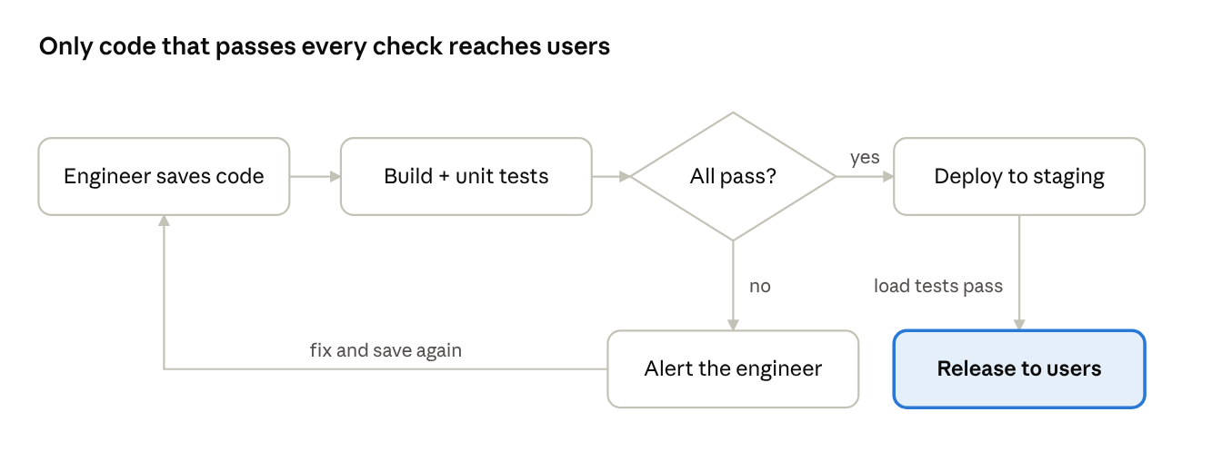
CI/CD pipeline · 5 steps, 1 check
If any step fails, the pipeline stops and the engineer is told at once. Broken code never reaches users.

Working in parallel
In class, the tasks were assigned to different engineers who work at the same time. This is the main reason we break work down so finely.
One engineer doing all 10 tasks of the two stories alone would need 50 hours (over a working week). With 5 engineers each taking one type of task across both stories, the work finishes much sooner, limited only by the order some tasks must follow.

Rules that make parallel work possible
- Agree the API contract first: frontend and backend agree on what data the API sends, so both can start at once.
- Use version control (Git): each engineer works on their own branch and merges carefully.
- Small tasks: smaller tasks cause fewer clashes.
- Daily stand-up: blockers are found and fixed every day.

11. Sprints, estimation and planning the whole project
Once the work is broken down, the team plans it into sprints: short 2-week cycles that each end with something working that users could see.

The sprint cycle
- Sprint Planning: the team picks the most important stories from the backlog that fit into the next 2 weeks.
- Daily Stand-up: 15 minutes each day: what I did, what I will do, what is blocking me.
- Development: engineers build, test and merge their tasks.
- Sprint Review: the team shows the finished work to the Product Owner (a demo).
- Sprint Retrospective: the team discusses what went well and what to improve.
- Repeat with the next sprint.

Two ways to estimate
Method | How it works | Example
Hours | Guess how many hours a task takes | Build React UI = 5 hrs
Story points | Give each story a size number compared to others (often 1, 2, 3, 5, 8, 13) | Track Packages = 8 points, Print Labels = 3 points
Class notes used hours for tasks. Many teams use story points for stories and hours for tasks.
Planning Poker is a common way to agree on story points: each person secretly picks a number card, everyone shows at once, and big differences are discussed.

Velocity
Velocity is how much work a team finishes in one sprint. If the team usually finishes 40 points per sprint, and the Epic is 400 points, it will take about 10 sprints, which is about 20 weeks (5 months).

Priority: what to build first
The Product Owner orders the backlog. A common method is MoSCoW:
Priority | Meaning | Example
Must have | Without it, the product fails | Track Packages, Cancel Orders
Should have | Important, but can wait a little | Return and Exchange
Could have | Nice extra | Print Labels at home
Won't have (for now) | Not in this release | Advanced Prime reports

Definition of Done
A task or story is only "Done" when all of these are true:
- ☐ Code is written and reviewed by another engineer.
- ☐ Unit tests are written and passing.
- ☐ It passes the CI/CD pipeline.
- ☐ It meets the acceptance criteria.
- ☐ It has passed load testing where needed.
- ☐ The Product Owner has accepted it.

